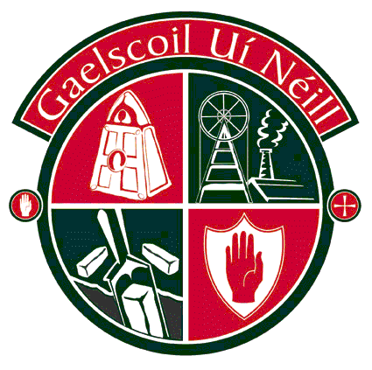
104 Bóthar an Chuain, 104 Washingbay Road,
Cluain Eo, Clonoe,
Oileán an Ghuail, Coalisland,
Tír Eoghain. Tyrone.
BT71 4PU BT71 4PU

Guthán: 028 87749178 Phone: 028 87749178
Facs: 028 87741101 Fax: 028 87741101
R-phost: gaelscoiluineill@yahoo.ie Email: gaelscoiluineill@yahoo.ie

25/09/18

A Thuismitheoirí:

Beidh an chéad seisiún ullmhaithe scrúdaithe ag an deireadh seachtaine againn ar an Satharn beag seo, 29^{ú} Meán Fómhair ó 9.45am go 12.00pm. Déanfaidh na daltaí dhá scrúdú ar an mhaidin chéanna agus gheobhaidh siad torthaí agus uisce idir an dá theist. Léirigh ar an liarlóg thíos cé acu an mbeidh do pháiste linn maidin Dé Sathairn nó nach mbeidh (cuirfear na teisteanna chun an bhaile más amhlaidh nach mbeidh).

Our first weekend session for exam preparation will take place this Saturday, 29th September from 9.45am to 12.00pm. Pupils will sit two tests in the same morning and will receive fruit and water between the tests. Please indicate on the Reply Slip below if your child will be attending (the tests in question will be sent home on Friday otherwise).

Is mise le meas,

Conor McPhillips
Príomhoide

Beidh / Ní bheidh mo pháiste (AINM) ______________________________________ ag an rang

ullmhaithe scrúdaithe ar an Satharn, 29^{ú} Meán Fómhair.

My child (NAME) ___________________________________________ will / will not be at the exam

preparation class this Saturday, 29th September.

Signature / Síniú _______________________________________ Dáta/Date________________

